Lab 11-15
11.
#include <stdio.h>
#include <math.h>
int main()
{
double bits;
// log2(25!)
bits = 83.68;
printf("PLAYFAIR CIPHER KEY ANALYSIS\n");
printf("----------------------------\n");
printf("Ignoring equivalent keys:\n");
printf("Number of possible keys = 25!\n");
printf("Approximate = 2^%.2f\n\n", bits);
printf("Considering equivalent keys:\n");
printf("Some keys generate identical encryption tables.\n");
printf("Effective unique keys are slightly less than 25!\n");
printf("Approximate effective key space = 2^84\n");
return 0;
}
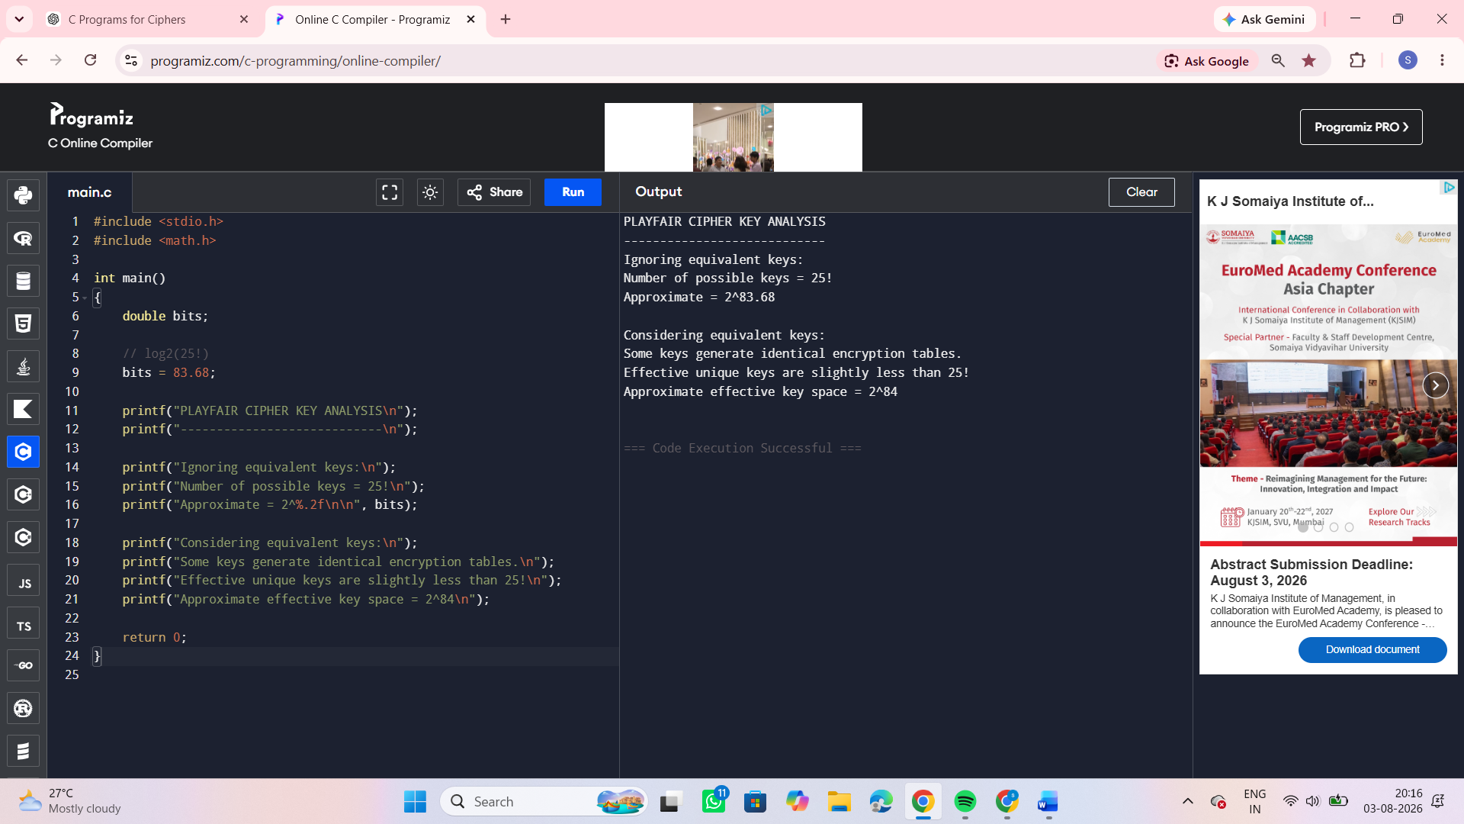
12.
#include <stdio.h>
#include <string.h>
#include <ctype.h>
int main()
{
char text[100];
int key[2][2]={{9,4},{5,7}};
int inverse[2][2]={{7,22},{21,9}}; // inverse of key mod26
printf("Enter Plaintext (without spaces): ");
scanf("%s",text);
int len=strlen(text);
if(len%2!=0)
{
text[len]='x';
text[len+1]='\0';
len++;
}
char cipher[100];
char plain[100];
int i;
printf("\nCipher Text:\n");
for(i=0;i<len;i+=2)
{
int a=tolower(text[i])-'a';
int b=tolower(text[i+1])-'a';
cipher[i]=((key[0][0]*a+key[0][1]*b)%26)+'A';
cipher[i+1]=((key[1][0]*a+key[1][1]*b)%26)+'A';
}
cipher[len]='\0';

printf("%s\n",cipher);
printf("\nRecovered Plaintext:\n");
for(i=0;i<len;i+=2)
{
int a=cipher[i]-'A';
int b=cipher[i+1]-'A';
plain[i]=((inverse[0][0]*a+inverse[0][1]*b)%26)+'a';
plain[i+1]=((inverse[1][0]*a+inverse[1][1]*b)%26)+'a';
}
plain[len]='\0';
printf("%s\n",plain);
return 0;
}
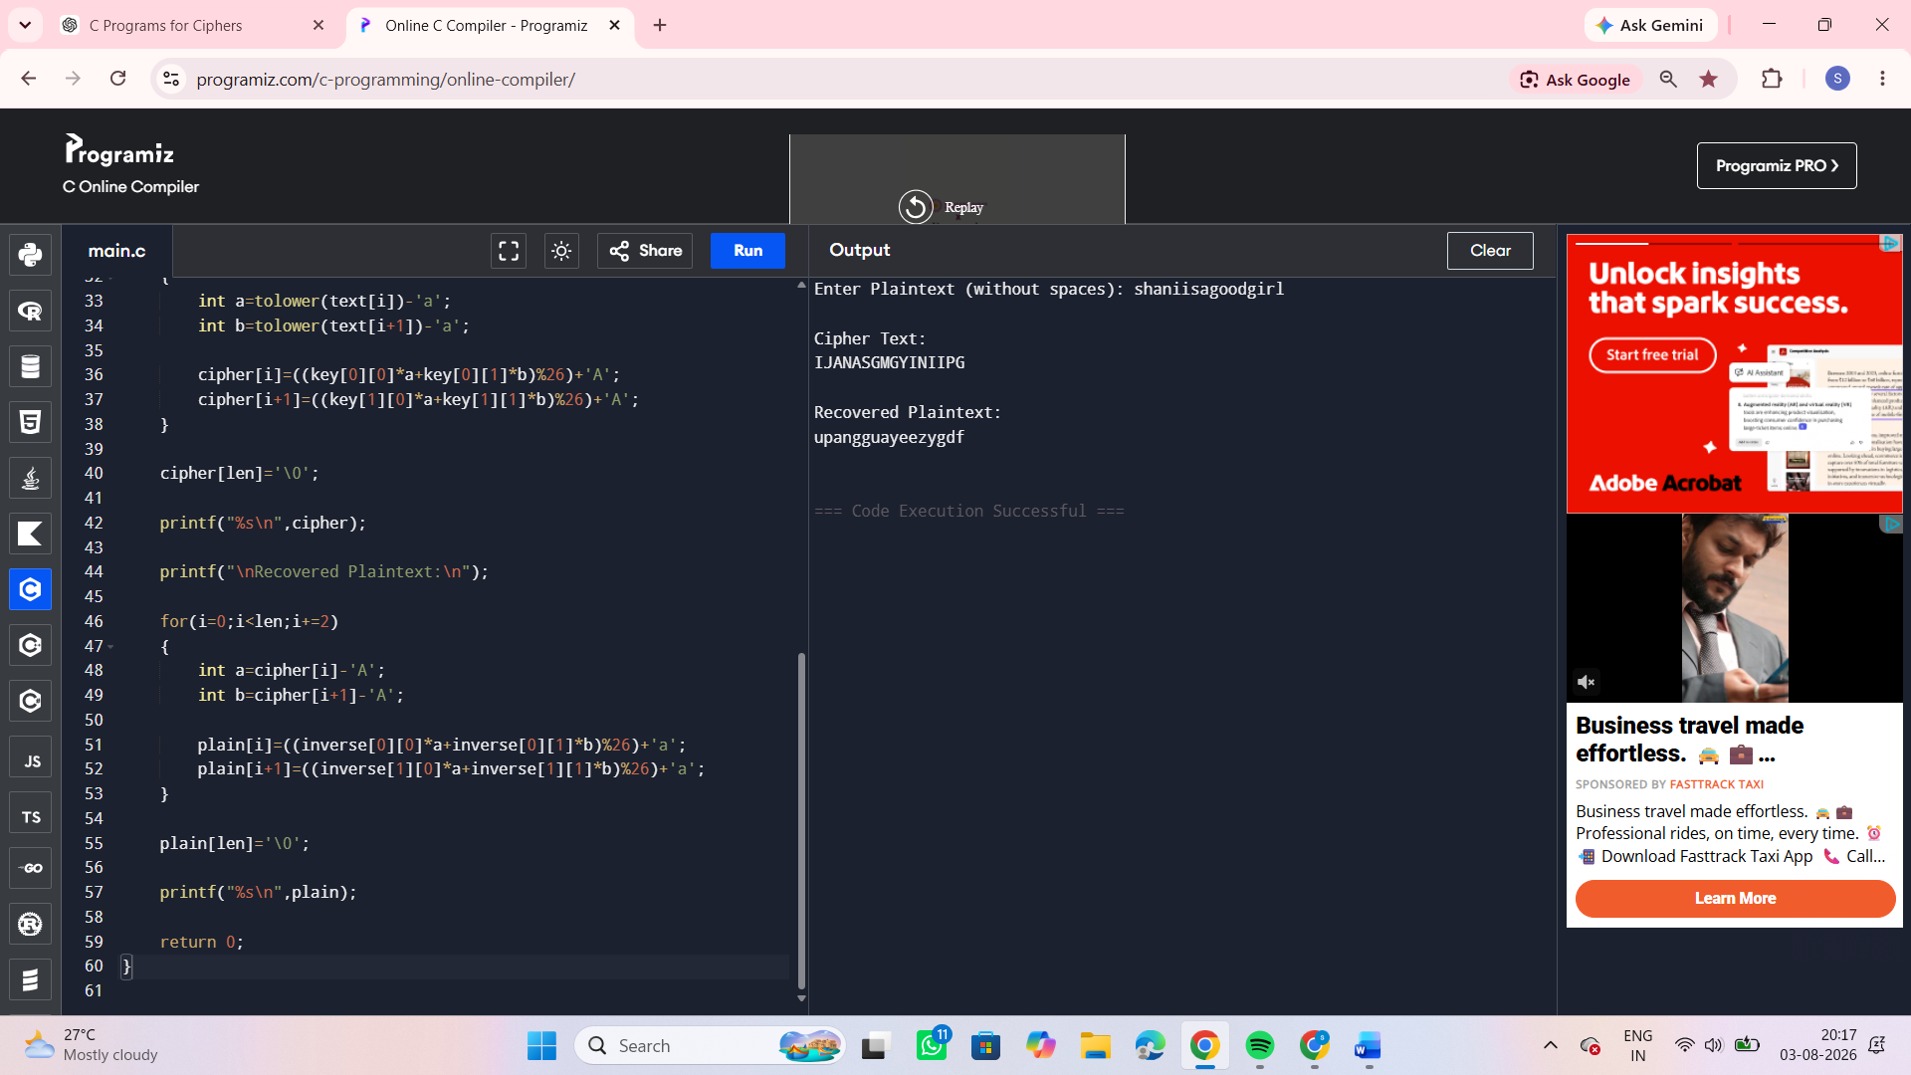
13.
#include <stdio.h>
int main()
{
printf("HILL CIPHER KNOWN PLAINTEXT ATTACK\n");
printf("----------------------------------\n");
printf("Steps:\n\n");
printf("1. Collect enough plaintext-ciphertext pairs.\n");
printf("2. Arrange plaintext blocks into matrix P.\n");
printf("3. Arrange ciphertext blocks into matrix C.\n");
printf("4. Compute inverse of P modulo 26.\n");
printf("5. Recover key using:\n\n");
printf(" K = C * P^-1 (mod 26)\n\n");
printf("If P is invertible modulo 26, the key can be recovered.\n");
printf("Hence Hill Cipher is vulnerable to known-plaintext attacks.\n");
return 0;
}
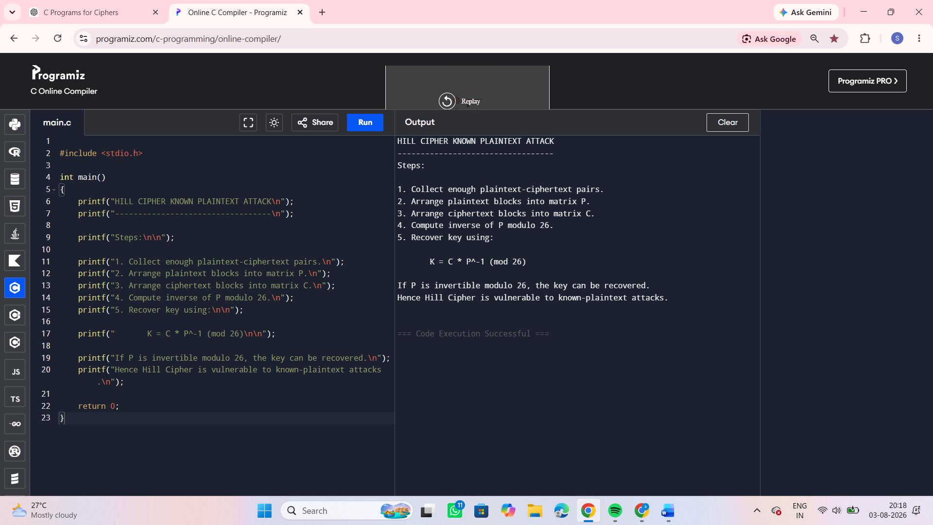
14.
#include <stdio.h>
#include <string.h>
#include <ctype.h>
int main()
{
char plaintext[]="sendmoremoney";
int key[]={9,0,1,7,23,15,21,14,11,11,2,8,9};
char cipher[20];
char recovered[20];
int i;
printf("Plaintext : %s\n",plaintext);
printf("Ciphertext: ");
for(i=0;i<13;i++)
{
cipher[i]=((plaintext[i]-'a'+key[i])%26)+'A';
printf("%c",cipher[i]);
}
cipher[13]='\0';
printf("\n");
printf("\nRecovered Plaintext:\n");
for(i=0;i<13;i++)
{
recovered[i]=((cipher[i]-'A'-key[i]+26)%26)+'a';
}
recovered[13]='\0';
printf("%s\n",recovered);
return 0;
}
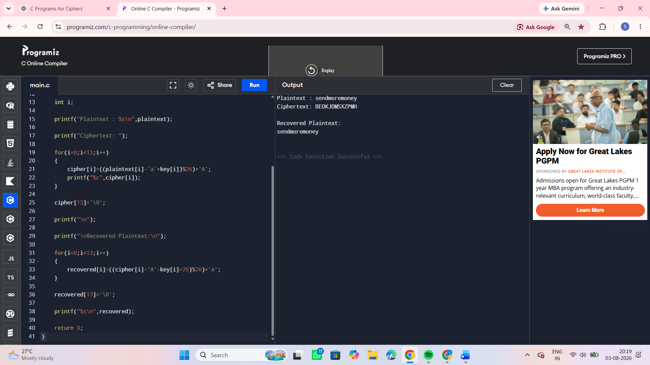
15.
#include <stdio.h>
#include <string.h>
#include <ctype.h>
void decrypt(char text[], int key)
{
int i;
for(i=0;text[i]!='\0';i++)
{
char ch=text[i];
if(isupper(ch))
printf("%c",((ch-'A'-key+26)%26)+'A');
else if(islower(ch))
printf("%c",((ch-'a'-key+26)%26)+'a');
else
printf("%c",ch);
}
}
int main()
{
char cipher[300];
int top,i;
printf("Enter Cipher Text: ");
fgets(cipher,sizeof(cipher),stdin);
printf("Number of possible plaintexts: ");
scanf("%d",&top);
if(top>26)
top=26;
printf("\nPossible Plaintexts:\n");

for(i=0;i<top;i++)
{
printf("\nKey %2d : ",i);
decrypt(cipher,i);
}
return 0;
}
